## Setup

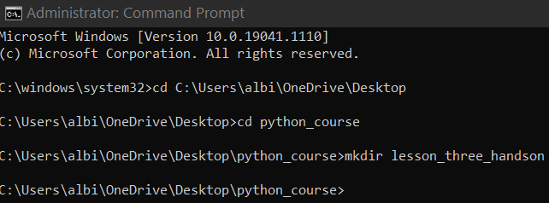

## Requirements

This hands-on is broken into three parts. Please complete each part within your main.py file.

## Part 1

1. Create a list of the following first names: Kurt, David, Katherine.
2. The variable name for the above list should be list_of_names.
3. Use a for loop to loop through each name in the list and print the following question: Where is _____ today?
4. Each name should replace the blank within the question.
5. The output should look like the following:

Where is Kurt today?

Where is David today?

Where is Katherine today?

Python commands:

list_of_names = ['Kurt', 'David', 'Katherine']

for name in list_of_names:

print("Where is " + name + " today?")

Results:

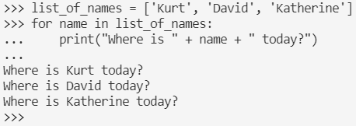

## Part 2

1. Create three separate lists with the following variable names: my_favorite_cars, my_favorite_flowers, my_favorite_animals

my_favorite_cars should include 3 different cars

my_favorite_flowers should include 4 different flowers

my_favorite_animals should include 5 different animals

1. Concatenate the above three lists into a single list named my_favorite_things.
2. Use a for loop to iterate over each element of the my_favorite_things combined list. Print out each item with an even length.

The output should show only items in the my_favorite_things list that have an even number of letters.

Python Commands:

my_favorite_cars = ['2021 Tesla Model 3', '2021 Toyota Corolla', '2021 Nissan Kicks']

my_favorite_flowers = ['Sunflower', 'Rose', 'Lotus', 'Orchid']

my_favorite_animals = ['Hamster', 'Cat', 'Dog', 'Goldfish', 'Rabbit']

my_favorite_things = my_favorite_cars + my_favorite_flowers + my_favorite_animals

print(my_favorite_things)

for thing in my_favorite_things:

if len(thing) %2 == 0:

print(thing)

Results:

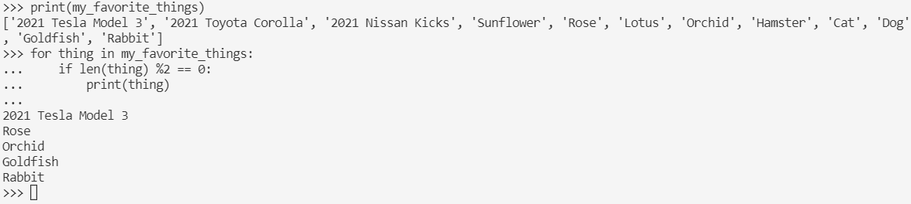

## Part 3

Finally, add to your program new code that does the following:

1. Create a list named number_range that includes the numbers 1 – 20.
2. Loop through the list.
3. For every number that is divisible by 3 and 5, print ZipZap.
4. For every number that is divisible by 3, print Zip.
5. For every number that is divisible by 5, print Zap.
6. If the number is not divisible by any of the three, then just print the number.

Python Commands:

number_range = list(range(1, 21))

print(number_range)

for number in number_range:

if number % 3 == 0 and number % 5 == 0:

print("ZipZap")

elif number % 3 == 0:

print("Zip")

elif number % 5 == 0:

print("Zap")

else:

print(number)

Results:

